LoRA (Low-Rank Adaptation), QLoRA (Quantized Low-Rank Adaptation)

How Researchers Solved a Billion-Dollar Problem

Part 1: The Beginning — When AI Models Became Giants
Start by asking your students:
"Guys, how many of you have heard about ChatGPT, Gemini, Llama, or DeepSeek?"
Wait for students to respond.
"Great! Almost everyone knows about these AI models.
But have you ever wondered how much computing power is needed to train these models?
Let's go back a few years.
In 2018, researchers introduced BERT. In 2019, GPT-2 became popular. Then, in 2020, OpenAI introduced GPT-3, which had 175 billion parameters.
Now imagine that! 175 billion parameters!
And every single parameter has a numerical value called a weight.
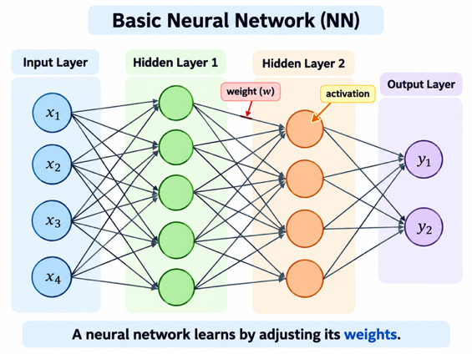
These models became extremely powerful. But as they grew bigger, researchers started facing a serious problem."

Part 2: The Problem — Imagine You Own an AI Company
"Let's imagine something interesting.
Suppose I start my own AI company.
I already have a pretrained language model, and I want to develop three applications.
The first application is a banking chatbot.
The second application is a medical assistant.
And the third application is a customer support chatbot.
Now, I don't want to train three large models from scratch. That's too expensive!
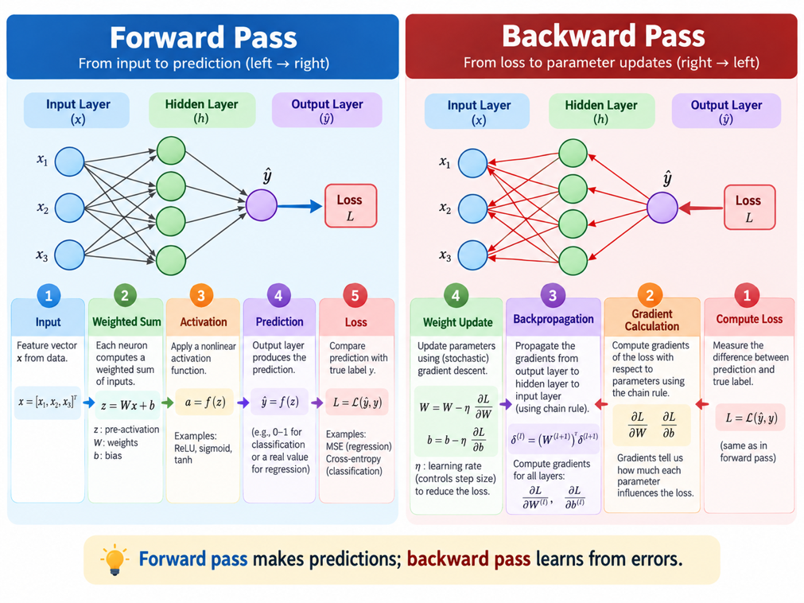
So I decide to take my existing pretrained model and fine-tune it separately for each application.
Sounds like a good idea, right?
But here's the problem.
Suppose my model has 175 billion parameters.
If I perform full parameter fine-tuning, I need to train all those parameters.
Not once, but separately for each task!
I need powerful GPUs, large amounts of memory, and expensive computing infrastructure.
And after training, if I save three complete FP16 model copies, each one takes approximately 350 GB.
That's more than one terabyte for just three models!
Now imagine I have 100 customers, and each customer wants a customized model.
Am I going to maintain 100 enormous model copies?"
Pause and look at the students.
"Of course, it's possible. But would it be efficient?
Not really!
And that's exactly the kind of problem researchers wanted to solve."

Part 3: The Big Idea — Why Train Everything?
"Now, imagine you're a researcher working on this problem.
One day, you ask yourself a simple question:
Why are we updating billions of parameters when our pretrained model already knows so much?
Think about it.
Our model already understands English, programming, science, mathematics, and many other subjects.
We only want to customize it for banking.
Do we really need to change the entire model?
What if we keep the original model unchanged and train only a small number of additional parameters?
That would save a huge amount of computing resources!
And this brings us to an important concept called Parameter-Efficient Fine-Tuning, or PEFT.
Researchers explored several ways to achieve this. And in 2021, a particularly powerful technique was introduced."

Part 4: The Hero Arrives — LoRA (2021)
"Everyone, meet LoRA — Low-Rank Adaptation!
LoRA was introduced in 2021 by Edward Hu and his colleagues.
Its idea was simple but powerful.
Don't update the original model's billions of weights. Freeze them!
Instead, add two small trainable matrices called A and B.
During fine-tuning, we train these small matrices rather than the original model weights.
Let me give you an example.
Suppose one weight matrix in our model contains one million parameters.
With full fine-tuning, we train all one million.
But with LoRA, using rank 8, we might only need to train 16,000 additional parameters for that matrix.
That's a reduction of 98.4% in trainable parameters!
Now imagine the difference in GPU memory and training costs.
Researchers were excited because LoRA made adapting large models much more practical.
But just when everyone thought the problem was solved, another problem appeared."

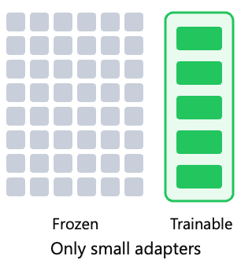

Part 5: The Plot Twist — LoRA Still Has a Problem!
"Here's where the story gets interesting.
LoRA says:
'Don't worry! You don't have to train those billions of original parameters anymore.'
And that's great.
But I have one question.
Where are we going to store the original model?
Remember, LoRA freezes the original model. It doesn't delete it!
Suppose we have a pretrained model with 65 billion parameters.
If we store the weights in FP16, we still need approximately 130 GB of memory just for the original weights.
Even though we're not updating these weights, they still need to be available during training.
Now imagine I have a GPU with only 24 GB of memory.
Can I fit 130 GB of model weights into 24 GB of GPU memory?
Wait for students to answer.
Exactly! Not without additional techniques such as offloading.
So LoRA solved one problem, but another remained.
Researchers had reduced the number of trainable parameters.
But they hadn't sufficiently reduced the memory required to store the enormous pretrained model.
And that's when another idea entered the picture."

Part 6: The Second Hero — QLoRA (2023)

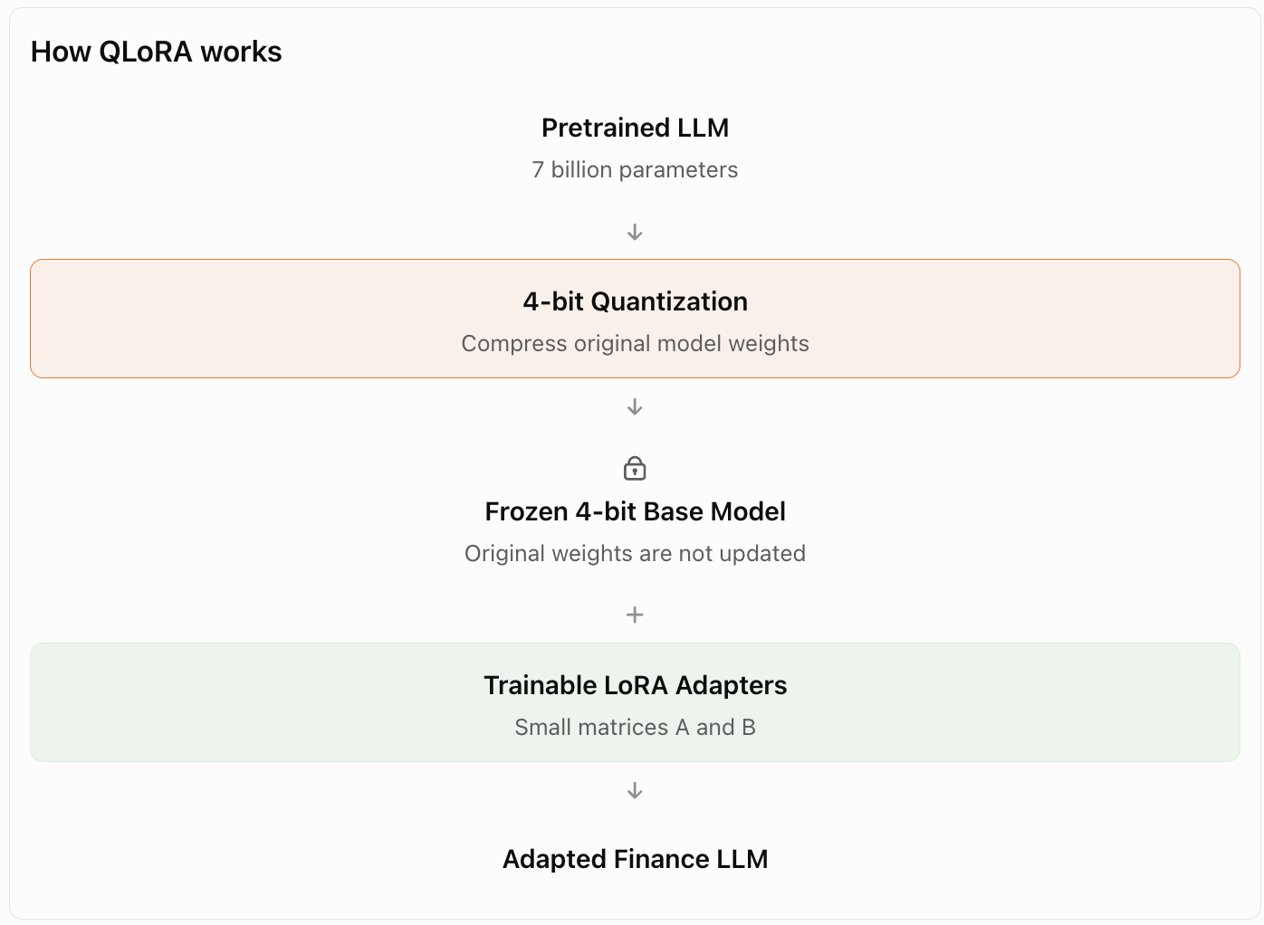

"Now we move to 2023.
Researchers introduced another technique called QLoRA — Quantized Low-Rank Adaptation.
And their idea was very interesting.
They said:
'We already have LoRA, which reduces the number of trainable parameters.
But what if we also compress the original pretrained model?'
Remember the quantization technique we studied earlier?
In quantization, we represent model weights using fewer bits.
For example, instead of storing the original weights in 16-bit floating-point precision, we can represent them using a 4-bit quantized format.
So QLoRA combines two techniques.
Quantization + LoRA = QLoRA
Let's return to our 65-billion-parameter model.
In FP16, the original weights require approximately 130 GB.
But in ideal raw 4-bit storage, they require approximately 32.5 GB.
That's a huge reduction!
Of course, real training requires additional memory for quantization information, adapters, and intermediate calculations.
But the improvement was substantial.
In fact, the QLoRA researchers demonstrated fine-tuning a 65-billion-parameter model on a single 48 GB GPU!
Think about that.
A model that previously required enormous training resources could now be adapted using much more accessible hardware.
And that's why QLoRA became such an important technique."

Part 7: The Ending — Three Generations of Thinking
"So, class, let's summarize our entire story.
Initially, we had Full Parameter Fine-Tuning.
It worked, but it required updating billions of parameters.
Then came LoRA in 2021.
LoRA said:
'Why update everything? Keep the original model frozen and train only small additional matrices.'
That reduced the number of trainable parameters dramatically.
But researchers still faced a memory problem because the frozen base model was enormous.
Then came QLoRA in 2023.
QLoRA said:
'Let's keep the benefits of LoRA, but also compress the frozen model using 4-bit quantization.'
And that's how researchers made fine-tuning large language models more memory-efficient.
Remember just three things:
- Full Fine-Tuning: Train the entire model.
- LoRA: Freeze the original model and train small additional matrices.
- QLoRA: Freeze and quantize the original model, then train small LoRA matrices.
So, LoRA was developed to reduce how many parameters need training.
And QLoRA was developed to reduce memory usage even further.
That's the story behind these two techniques!"

